1. See functions below

|  |  |  |  |  |
| --- | --- | --- | --- | --- |
| Solver | # iterations to converge | CPU time(s) | mdot_tot | phidot_tot |
| Jacobi | 2445 | 283.98 | 0.00E+00 | -5.79E-06 |
| GS | 1213 | 135.87 | 0.00E+00 | -5.90E-06 |
| GS_SOR, w=1.0 | 1213 | 143.97 | 0.00E+00 | -5.90E-06 |
| GS_SOR, w=1.1 | 990 | 117.54 | 0.00E+00 | -5.87E-06 |
| GS_SOR, w=1.2 | 803 | 95.22 | 0.00E+00 | -5.93E-06 |
| GS_SOR, w=1.3 | 645 | 76.45 | 0.00E+00 | -5.92E-06 |
| GS_SOR, w=1.4 | 509 | 60.60 | 0.00E+00 | -5.92E-06 |
| GS_SOR, w=1.5 | 390 | 46.29 | 0.00E+00 | -5.97E-06 |
| GS_SOR, w=1.6 | 284 | 33.64 | 0.00E+00 | -6.17E-06 |
| GS_SOR, w=1.7 | 188 | 22.30 | 0.00E+00 | -6.13E-06 |
| GS_SOR, w=1.8 | 87 | 10.31 | 0.00E+00 | -4.99E-06 |
| GS_SOR, w=1.9 | 137 | 16.24 | 0.00E+00 | 1.95E-07 |
| GS_SOR, w=2.0 | did not converge | | | |

* + 1. The optimum value of ω for GS_SOR is near 1.8
    2. Number of iterations required for convergence: Jacobi = 2445, GS = 1213, GS_SOR_optimal = 87
    3. Mass is completely conserved in every case. The total mDot is 0 for every case. Φ is converged within 5.79e-6 for Jacobi, within 5.90e-6 for GS, and within 4.99e-6 for GS_SOR_optimal. In this case, the optimal GS_SOR also had the minimum error in Φ.
    4. The reduction in iterations from Jacobi to GS is very nearly 50%, as discussed in lecture. Although the same sweep direction was used throughout the process, no major errors appeared to accumulate during the solution. The optimal GS_SOR solver was much faster to convergence than either the Jacobi or GS cases, and was approximately 3X the number of grid points in one direction. The optimal GS_SOR solver required 3.5% the number of iterations of Jacobi and 7% the number of iterations of standard GS.

|  |  |  |  |  |
| --- | --- | --- | --- | --- |
| Solver | # iterations to converge | CPU time(s) | mdot_tot | phidot_tot |
| Jacobi | 4834 | 542.79 | 0.00E+00 | -5.79E-12 |
| GS | 2407 | 271.62 | 0.00E+00 | -5.92E-12 |
| GS_SOR, w=1.0 | 2407 | 293.08 | 0.00E+00 | -5.92E-12 |
| GS_SOR, w=1.1 | 1965 | 265.04 | 0.00E+00 | -5.94E-12 |
| GS_SOR, w=1.2 | 1596 | 212.10 | 0.00E+00 | -5.97E-12 |
| GS_SOR, w=1.3 | 1283 | 153.68 | 0.00E+00 | -5.99E-12 |
| GS_SOR, w=1.4 | 1014 | 121.02 | 0.00E+00 | -5.95E-12 |
| GS_SOR, w=1.5 | 778 | 93.00 | 0.00E+00 | -6.12E-12 |
| GS_SOR, w=1.6 | 569 | 67.81 | 0.00E+00 | -6.16E-12 |
| GS_SOR, w=1.7 | 378 | 45.79 | 0.00E+00 | -5.96E-12 |
| GS_SOR, w=1.8 | 171 | 20.38 | 0.00E+00 | -4.94E-12 |
| GS_SOR, w=1.9 | 275 | 32.80 | 0.00E+00 | 1.82E-12 |
| GS_SOR, w=2.0 | did not converge | | | |

* + 1. Number of iterations required for convergence: Jacobi = 4834, GS = 2407, GS_SOR_optimal = 1.8
    2. CPU time required for convergence: Jacobi = 543 s, GS = 272 s, GS_SOR_optimal = 20.38 s
    3. Plots of the maximum iteration error magnitude (errmax) as a function of iteration number for Jacobi, GS and optimal GS_SOR are shown below. All curves have very similar shapes, but the convergence rate of the GS is twice as fast as the Jacobi, and the optimal GS_SOR is much faster than either Jacobi or GS (note the differing x-axis scales).
    4. Plots of the maximum residual magnitude (resmax) as a function of iteration

number for Jacobi, GS and optimal GS_SOR are shown below. Interestingly, the rate of convergence for residual error magnitude appears to be much faster than for error magnitude. Additionally, the optimal GS_SOR appears to have some slight oscillitory behavior.

Error magnitude plots

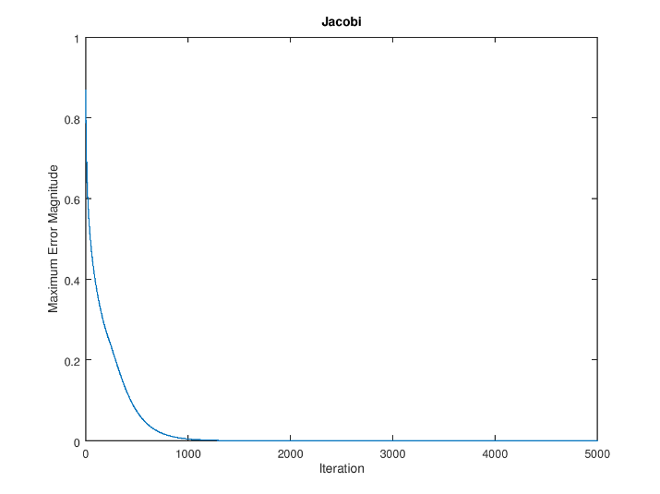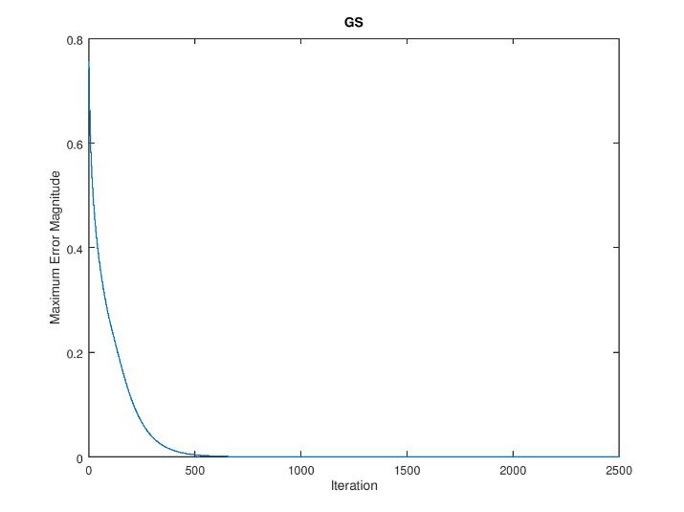

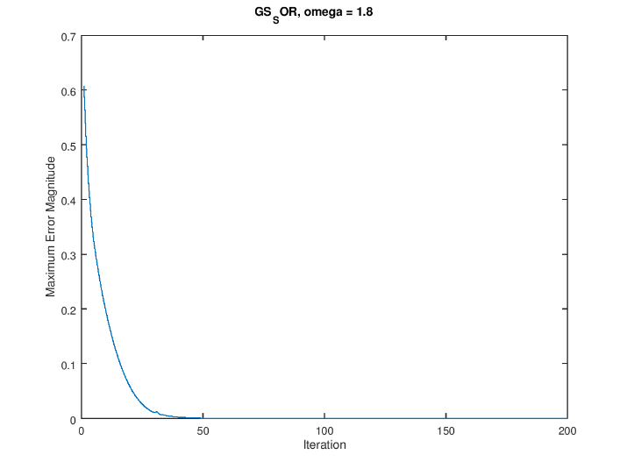

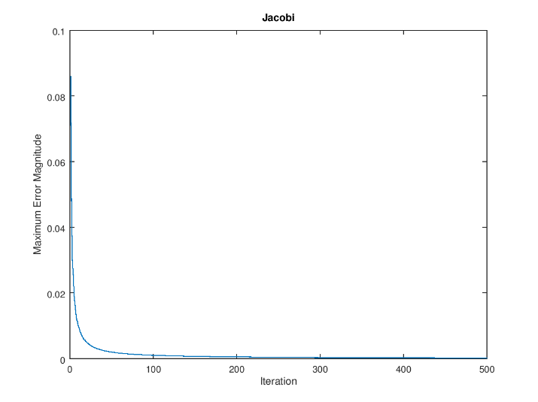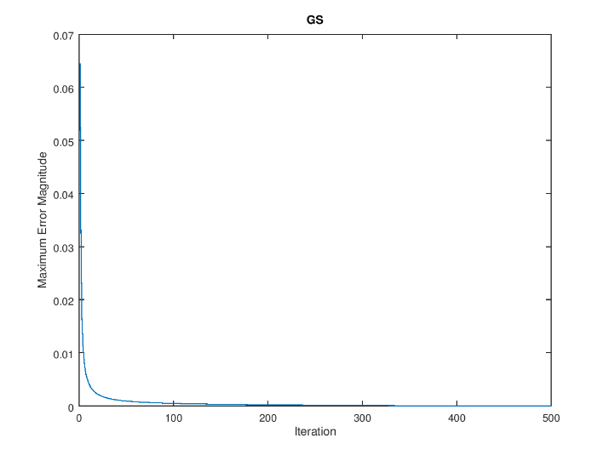Below are the residual magnitude plots (ignore the y-axis label):

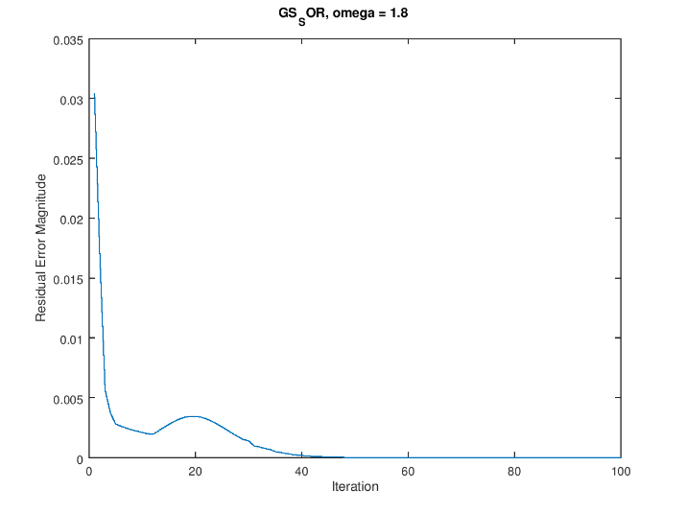

Defined functions:

%%% begin jacobi %%%

function jacobi

% globals needed

global ap ano aso aea awe q phidir n m epsit resmax errmax nitmax xc yc

global phiold phinew iterstore

iterstore = 0; % storage variable for iteration count

phiold = phidir; % initialize array for "old" phi values

phinew = phidir; % initialize array for "new" phi values

resTemp = zeros(m, n); % initialize local array to store residuals

% set internal nodes to be zero

phiold(2:end-1, 2:end-1) = 0;

phinew(2:end-1, 2:end-1) = 0;

nit = 0;

while max(max(abs(phidir - phinew))) > epsit*max(max(phinew));

nit = nit + 1;

for j = 2:m+1

for i = 2:n+1

phinew(i, j) = (q(i,j) - ano(i,j)*phiold(i,j+1) ...

- aso(i,j)*phiold(i,j-1) ...

- aea(i,j)*phiold(i+1,j) ...

- awe(i,j)*phiold(i-1,j))/ap(i,j);

end

end

errmax(nit) = max(max(abs(phidir - phinew)));

% Periodically show results

if mod(nit, 50) == 0

fprintf('Jacobi iteration %.0f, errmax %.4e\n', nit, errmax(nit));

end

for j = 2:m+1

for i = 2:n+1

resTemp(i,j) = q(i,j) - ano(i,j)*phinew(i,j+1) ...

- aso(i,j)*phinew(i,j-1) ...

- aea(i,j)*phinew(i+1,j) ...

- awe(i,j)*phinew(i-1,j) ...

- ap(i,j)*phinew(i,j);

end

end

resmax(nit) = max(max(resTemp));

phiold = phinew;

phi = phinew;

iterstore = nit; % save number of iterations in global var

% Break out of the while loop if maximum number of iterations is reached

if nit == nitmax;

break

end

end % end while loop

if nit == nitmax;

fprintf('Jacobi solution did not converge in %4.0f iterations.\n', nitmax)

else

fprintf('Jacobi solution converged in %4.0f iterations.\n', nit)

end

end

%%% end jacobi %%%

%%% begin gs

function gs

% globals needed

global ap ano aso aea awe q phidir n m epsit resmax errmax nitmax xc yc

global phinew iterstore

iterstore = 0; % storage variable for iteration count

phinew = phidir; % initialize array for "new" phi values

resTemp = zeros(m, n); % initialize local array to store residuals

% set internal nodes to be zero

phinew(2:end-1, 2:end-1) = 0;

nit = 0;

while max(max(abs(phidir - phinew))) > epsit*max(max(phinew));

nit = nit + 1;

for j = 2:m+1

for i = 2:n+1

phinew(i, j) = (q(i,j) - ano(i,j)*phinew(i,j+1) ...

- aso(i,j)*phinew(i,j-1) ...

- aea(i,j)*phinew(i+1,j) ...

- awe(i,j)*phinew(i-1,j))/ap(i,j);

end

end

errmax(nit) = max(max(abs(phidir - phinew)));

% Periodically show results

if mod(nit, 50) == 0

fprintf('GS iteration %.0f, errmax %.4e\n', nit, errmax(nit));

end

for j = 2:m+1

for i = 2:n+1

resTemp(i,j) = q(i,j) - ano(i,j)*phinew(i,j+1) ...

- aso(i,j)*phinew(i,j-1) ...

- aea(i,j)*phinew(i+1,j) ...

- awe(i,j)*phinew(i-1,j) ...

- ap(i,j)*phinew(i,j);

end

end

resmax(nit) = max(max(resTemp));

phiold = phinew;

phi = phinew;

iterstore = nit; % save number of iterations in global var

% Break out of the while loop if maximum number of iterations is reached

if nit == nitmax;

break

end

end % end while loop

if nit == nitmax;

fprintf('GS solution did not converge in %4.0f iterations.\n', nitmax)

else

fprintf('GS solution converged in %4.0f iterations.\n', nit)

end

end

%%% end of gs

%%% begin gs_sor

function gs_sor

% globals needed

global ap ano aso aea awe q phidir n m epsit resmax errmax nitmax xc yc

global phinew omega phiold iterstore

iterstore = 0; % storage variable for iteration count

phinew = phidir; % initialize array for "new" phi values

phiold = phidir; % initialize array for "old" phi values

resTemp = zeros(m, n); % initialize local array to store residuals

% set internal nodes to be zero

phiold(2:end-1, 2:end-1) = 0;

phinew(2:end-1, 2:end-1) = 0;

nit = 0;

while max(max(abs(phidir - phinew))) > epsit*max(max(phinew));

nit = nit + 1;

for j = 2:m+1

for i = 2:n+1

phinew(i, j) = omega*(q(i,j) - ano(i,j)*phiold(i,j+1) ...

- aso(i,j)*phinew(i,j-1) ...

- aea(i,j)*phiold(i+1,j) ...

- awe(i,j)*phinew(i-1,j))/ap(i,j) ...

+ (1-omega)*phiold(i,j);

end

end

errmax(nit) = max(max(abs(phidir - phinew))); % compute errmax

% Periodically show results

if mod(nit, 50) == 0

fprintf('GS-SOR [%1.1f] iteration %.0f, errmax %.4e\n', omega, nit, ...

errmax(nit));

end

for j = 2:m+1

for i = 2:n+1

resTemp(i,j) = q(i,j) - ano(i,j)*phinew(i,j+1) ...

- aso(i,j)*phinew(i,j-1) ...

- aea(i,j)*phinew(i+1,j) ...

- awe(i,j)*phinew(i-1,j) ...

- ap(i,j)*phinew(i,j);

end

end

resmax(nit) = max(max(resTemp));

phiold = phinew;

phi = phinew;

iterstore = nit; % save number of iterations in global var

% Break out of the while loop if maximum number of iterations is reached

if nit == nitmax;

break

end

end % end while loop

if nit == nitmax;

fprintf('GS-SOR [w=%1.1f] did not converge in %4.0f iterations.\n', ...

omega, nitmax)

else

fprintf('GS-SOR [w=%1.1f] converged in %4.0f iterations.\n', ...

omega, nit)

end

end

%%% end of gs_sor